Antimycobacterial preparations
Antimycobacterial drugs - drugs used in the treatment of diseases caused by mycobacteria. Mycobacteria are gram (+) bacteria and stain poorly. Since these are acid-resistant bacteria, they cannot be stained with alcohol or acid. This is due to the fact that the cell wall is rich in lipids. For this reason, these bacteria are resistant to many chemotherapeutic drugs. There are many types of mycobacteria, but the most important from a clinical and microbiological point of view are listed below.
1) Tuberculosis
2) leprosy
3) Dissemine M.avium — the causative agent of complex diseases.
Medicines used in the treatment of tuberculosis
Tuberculosis, a chronic disease, mainly occurs in the lungs. This disease can affect the lymphatic system, nervous system, genitourinary and gastrointestinal tract. The causative agent of the disease is mycobacterium tuberculosis, isolated by Robert Koch in 1882. M.bovis and M.africanum are also bacteria that cause tuberculosis. Atypical mycobacteria (M. marinum, M. avium intracellulare) cause tuberculosis-like diseases.
M.tuberculosis is a slowly developing bacterium capable of reproduction over a long period of time, capable of living intracellularly and with difficulty amenable to treatment. Since the symptoms of tuberculosis are hidden, diagnosis of the disease is carried out radiologically. The tuberculin test is also important in the diagnosis of the disease. The main symptom of tuberculosis is cough. Other symptoms of the disease are tachycardia, hypotension, shortness of breath and cyanosis. Tuberculosis is an infectious disease, the development of which leads to the death of the patient. Therefore, it is also necessary to examine persons who have been in contact with tuberculosis patients or their relatives for a long time. Even if there is no disease, sometimes relatives of the patient should use the medicine for preventive purposes. Even tuberculosis can recur several years after recovery. Therefore, these people should be extremely careful and not use cigarettes and alcoholic beverages.
Tuberculosis is an infectious disease with very high mortality, found on all continents and in all countries. In 2015, 10.4 million people worldwide were infected with this disease, the number of which is increasing recently, and 1.8 million of them died. WHO has declared a tuberculosis emergency. Tuberculosis is most common in Southeast Asia and Africa. At the same time, half of the diseases are accounted for in India, China and Indonesia. In the past, tuberculosis was known as a disease of poor and disadvantaged people.
Bacillus Calmette Guerin vaccine, discovered by French researchers Albert Calmette and Camilla Guerin for the prevention of tuberculosis, was obtained in 1920 from the culture of bovine tuberculosis bacilli, incubated for 13 years in bile and potato glycerin. Live bacteria with reduced pathogenicity obtained in this way cause immunity in humans without causing diseases. In our country BCG vaccination is carried out by the state once two months after the birth of the baby. BCG vaccination is not recommended for unvaccinated children older than 6 years.
In developed countries, where tuberculosis is less common, BCG is not required. There are methods of treating tuberculosis that were used until the 1930s, but nowadays they are considered ineffective. The beginning of the treatment of mycobacteria is considered to be the first research conducted by scientists Rich and Follis in 1938 with sulfonamides. Subsequently, the antimycobacterial effect of several derivative sulfonamides was investigated. However, the difference between the therapeutic dose and the toxic dose of these compounds was insignificant. Antimycobacterial activity of dapsone in 1939, paraaminosalicylic acid in 1944, thiacetazone in 1946, isoniazid and pyrazinamide in 1952 was investigated. Ethambutol, synthesized in 1961, received FDA approval in 1968.
The antituberculosis effect of streptomycin, isolated by Vaksman and colleagues in 1944, was studied. After studying the antimycobacterial action of other antibiotics, viomycin, cycloserine, kanamycin, capreomycin and rifampicin were found.
In order to prevent the formation of resistant strains of tubercle bacilli, medical chemists who pay attention to the joint use of two or three drugs in the clinic have synthesized new antimycobacterial drugs by combining separate antimycobacterial substances to overcome this problem. These drugs include metazide (isoniazid molecule duplication), pashidrazid (paraaminosalicylic acid hybridization with isoniazid), streptonicoside (streptomycin and isoniazid hybridization) and terizidone (cycloserine molecule duplication).
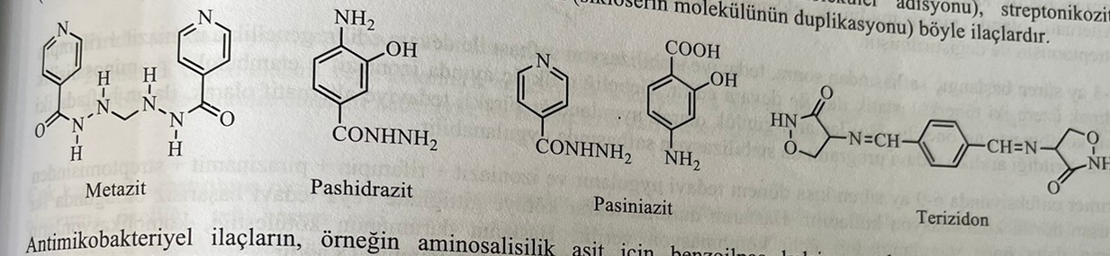
Latent forms of antimycobacterial drugs, for example: benzoylpas calcium for aminosalicylic acid, acedapson and diatimosulfan for dapsone, ftivazide and sulfoniazid for isoniazid, have been developed.
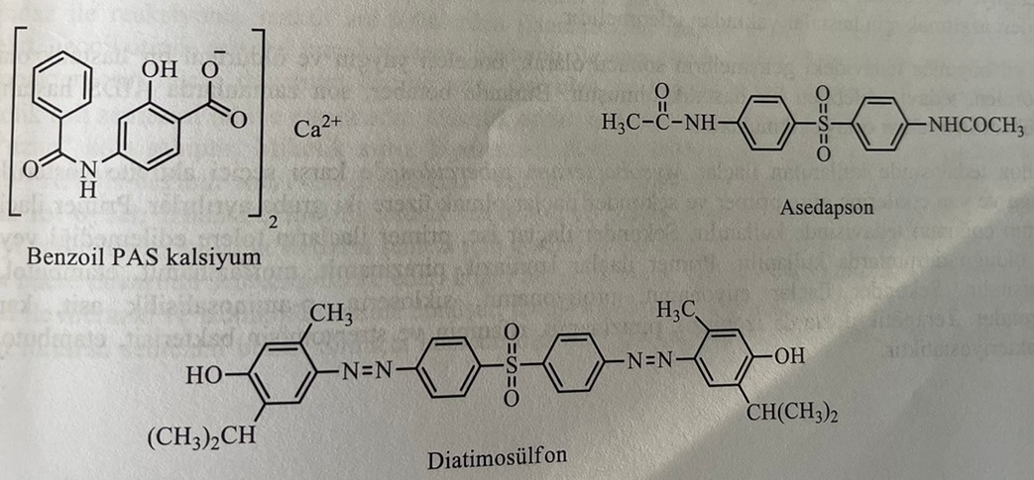
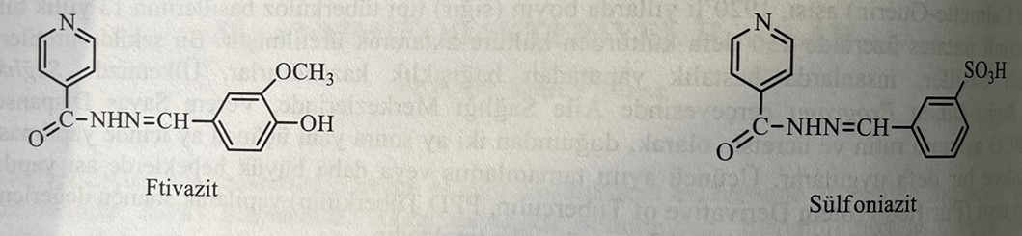
The chemical classification of drugs used in the treatment of tuberculosis is as follows:
1) Aminosalikats and their derivatives: p-Aminsalicylic acid, benzoylpas calcium, pashidrazid and paziniazid
2) Antibiotics and their derivatives: rifampin, streptomycin sulfate and cycloserine
3) Heterocyclic amides: ethionamide, prothionamide, pyrazinamide and morphazinamide.
4) Hydrazides and their derivatives: isoniazid, metazid and ftivazid.
5) Other compounds: hydrochloride ethambutola and thiacetazone.
6) Combinations: isoniazid + rifampin, isoniazid + pyrazinamide + rifampin
Because the disease is chronic, the treatment period is long. In long-term treatment, the use of the drug for injections is inappropriate. Therefore, the majority of drugs used in the treatment of tuberculosis are intended for oral administration. Antimycobacterial drugs should be prescribed in combination with other antibiotics due to rapid resistance to the drug.
At the first stage of tuberculosis treatment, three-component combined therapy is used until bacteria are detected in the sputum. Rapid resistance to antimycobacterial drugs is the reason for the application of combined therapy. Patients with low bacterial load are treated with two types of drugs. The previously used combination of streptomycin + p-aminosalicylic acid + isoniazid is currently replaced by the combination of isoniazid + rifampicin + ethambutol. As an alternative, it is used in a quadruple combination, to which pyrazinamide is also added.
After the initial phase of treatment lasting two to three months, the stabilization phase begins. In this phase, the double combination of isoniazid + rifampicin is mainly used. The combination of isoniazid + ethambutol + p-aminosalicylic acid is recommended to be used in the first trimester of pregnancy. In addition to continuous treatment, in which these drugs are used daily, they also begin a course of treatment in which they are used twice a week in the stabilization phase.
The primary infection is treated for 6-9 months, using a combination of isoniazid + rifampin + pyrazinamide + streptomycin. When starting chemotherapy, the sensitivity of bacteria to the drugs used should be taken into account. It is recommended to keep the patient under observation to avoid possible side effects.
As a result of the improvement of treatment over the last 50 years, tuberculosis, which was once common, has now become a rare disease. Drugs used in the treatment of tuberculosis have a selective effect against tuberculosis mycobacteria. According to therapeutic compatibility and side effects, these drugs are divided into 2 groups: primary and secondary antimycobacterial drugs. Primary drugs are used in the immediate treatment of tuberculosis. Secondary preparations are used to prevent bacterial resistance to the first preparations. First-line drugs include isoniazid, pyrazinamide, morphonisamid, ethambutol, rifampicin and streptomycin. Secondary drugs include ethionamide, prothionamide, cycloserine, p-aminosalicylic acid, capreomycin and thiacetazone. In therapeutic doses, isoniazid, pyrazinamide, rifampin and streptomycin have a bactericidal effect, and ethambutol and secondary drugs have a bacteriostatic effect.
Primary preparations
Isoniazid: hydrazide of 4-pyridinecarbonic acid.
Isoniazid, hydrazide of isonicotinic acid, is obtained by condensation of methylisonicotinic acid with hydrazine hydrate in ethanol medium.
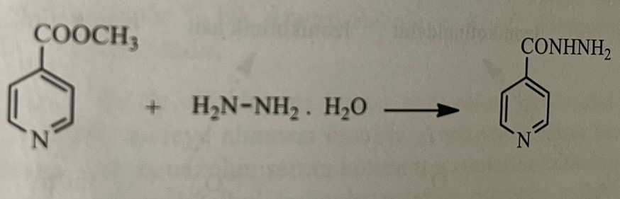
Isoniazid is considered more effective than other drugs used against Mycobacterium tuberculosis.
Structure-activity relationships of isoniazid and its derivatives
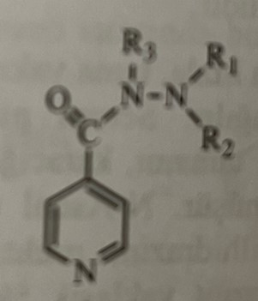

1) Addition of hydrazide to the second or third position in the structure causes a decrease in activity.
2) Inactive compounds are obtained by converting hydrazide into hydroxamic acid or other carbonyl compounds.
3) When adding alkyl or arylalkyl to the hydrazide structure, various pharmacological effects are shown. Addition of alkyl groups to the second nitrogen atom (R1 and R2 = alkyl, R3 = H) leads to active compounds, and replacement of the hydrogen attached to the first nitrogen atom to alkyl groups (R1 and R2 = H, R3 = alkyl) leads to its disappearance activity. None of these changes lead to a more active compound than isoniazid. As a result of the conducted studies, it was established that the nitrogen atom at the terminal end of hydrazine in the structure should possess the main property to ensure activity. Iproniazid, obtained by adding an isopropyl group to the terminal nitrogen atom of hydrazide, also has an anti-tuberculosis effect.
4) Addition of a radical to a pyridine ring leads to a decrease in activity.
5) Hydrazone compounds are obtained as a result of the reaction of isoniazid with various aldehydes or ketones. These compounds are quickly hydrolyzed in the body to isoniazid. Therefore, synthesized derivatives of hydrazone possess isoniazid activity.
Despite numerous large-scale studies, the mechanism of action of isoniazid has not yet been clarified. The chelating properties of the compound are insufficient to clarify the mechanism of action. It is believed that isoniazid disrupts the synthesis of the cell wall of mycobacteria, affecting the permeability of cells. It was established that isoniazid is activated by oxidation by an endogenous enzyme. The enzyme katG, possessing catalase-peroxidase activity, converts isoniazid into a reactive form capable of acylating only the enzyme system of M.tuberculosis. The reaction of isoniazid with catalase-peroxidase leads to the formation of isonicotinic aldehyde, isonicotinic acid and isonicotinamide. These products, in turn, form the isonicotinin radical or isonicotin peroxide. As a result of some studies, it has been established that isoniazid inhibits the synthesis of mycolic acid, which is an important part of the cell wall of mycobacteria and prevents the passage of hydrophilic substances. Mycolic acid is a lipid with alpha branching. It has short branches of 20-24 carbon atoms and long branches of 50-60 carbon atoms. Biosynthesis of mycolic acid is carried out by restoring NADH. Thus, the enzyme "NADH-dependent inchA-enoylreductase" synthesized under the control of the inhA gene plays an important role in the restoration of the double bond during the elongation of the fatty acid chain. Isoniazid specifically inhibits the synthesis of long-chain fatty acids. By acylating NAD+, it prevents the restoration of fatty acids necessary for the synthesis of mycolic acid, and stops the synthesis of the cell wall of mycobacteria. According to other considerations, isoniazid turns into hydrazine and isonicotinic acid under the action of the peroxidase enzyme entering the bacterial cell. Isonicotinic acid is an antimetabolite of nicotinic acid in bacteria and disrupts the synthesis of coenzymes. As a result, the metabolism of hydrogen peroxide in the cell does not take place, and the hydrogen peroxide accumulated inside the cell has a bactericidal effect.
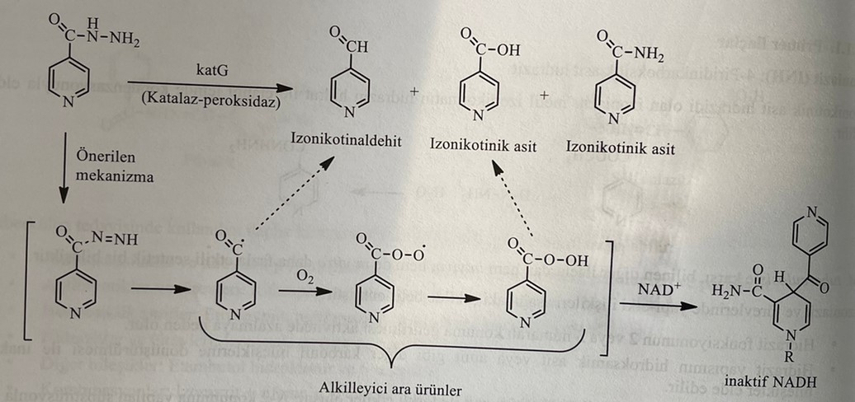
Isoniazid is an effective bactericidal drug. It is used separately for prevention and in combination with other drugs in the treatment of tuberculosis. The drug acts as an antagonist of pyridoxine and prevents deficiency of vitamin B6. This leads to the development of peripheral neuritis. Therefore, patients receiving isoniazid are recommended to take vitamin B6.
The drug is easily soluble in water, quickly absorbed after ingestion. It binds well to all body fluids and tissues, including cerebrospinal fluid. The drug reaches its peak plasma level after 1-2 hours. Bioabsorption is 90%. It can be said that most of it undergoes N-acetylation in the liver and turns into inactive metabolites. The remaining part is subjected to partial hydroxylation and turns into active isonicotinic acid. Hydrolysis of the N-acetyl derivative gives monoacetylhydrazin, and then diacetylhydrazin. Monoacetylhydrazine causes liver necrosis, catalyzed by N-hydroxyacetohydrazide. About 70% of the oral dose is excreted in the urine within 24 hours. The drug also penetrates into breast milk, feces and saliva. The rate of acetylation shows genetic variability. Because of the genetic difference, slow acetylators have less enzyme N-acetyltransferase in the liver than normal people, which leads to slow inactivation of isoniazid. The speed of inactivation of isoniazid in such persons is 5-6 times slower than in healthy persons. The half-life period is 0.5-1.6 hours for rapidly acetylating organisms and 2-5 hours for slowly acetylating organisms. When treating slow acetylators with high doses of isoniazid, the drug can accumulate in the body (cumulation). This can lead to many side effects, including peripheral neuritis. In some countries, there are a large number of slow acetylators. For example: 60% among Turks, 45-65% among Americans, 60% among Europeans, 10% among Eskimos, East Asian races and Japanese.
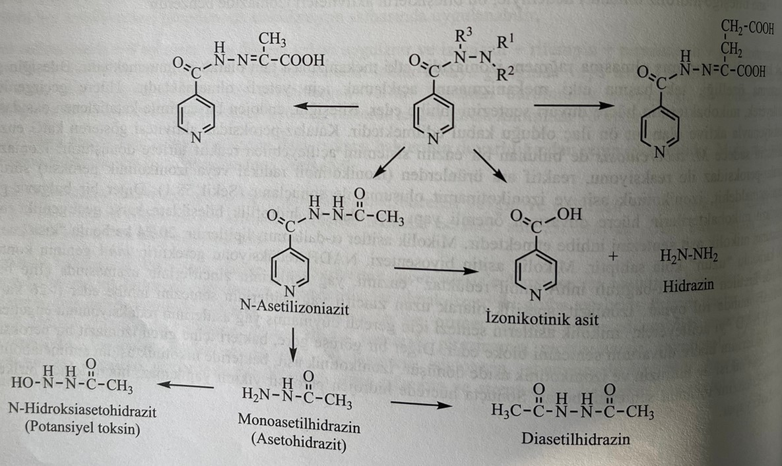
Food products and various antacids (mainly aluminum antacids) can reduce or slow down the absorption of isoniazid. Therefore, it is recommended to take the drug on an empty stomach. Use with anticoagulants may increase the anticoagulant effect. Ketoconazole reduces the level of ketoconazole in plasma in those who take ketoconazole. This increases the concentration of phenytoin in plasma in those who take phenytoin. Hepatotoxic effect of isoniazid increases due to induction of liver enzymes in alcoholics and people using rifampicin.
The disadvantage of the drug is the hepatotoxic effect of isoniazid, which is used in the treatment of tuberculosis. As a result of recent studies, it has been established that the hepatotoxic effect of isoniazid is less in patients older than 35 years. Hepatotoxicity is mainly observed in elderly patients. At the same time, this risk is observed to a greater extent in women than in men.
The occurrence of side effects of isoniazid depends on the applied dose. Peripheral neuritis is the most common side effect. The reason for peripheral neuritis is that isoniazid is chemically similar to pyridoxine/pyridoxal. Vitamin B6 is used to prevent peripheral neuritis (neuropathy). Renal excretion of pyridoxine increases twice when treated with isoniazid. Optic neuritis is rarely observed. In very rare cases, allergic reactions, skin rash, etc. may occur. Abnormal results of liver function tests may appear after using the drug. Ophthalmological examination is important for the timely diagnosis of optic neuritis.
Pyrazinamide: pyrazincaboxamide
This is a drug obtained during the research of heterocyclic analogs of nicotinamide. It is a bioisoster of nicotinamide and has an antibacterial effect against M. Tuberculosis.
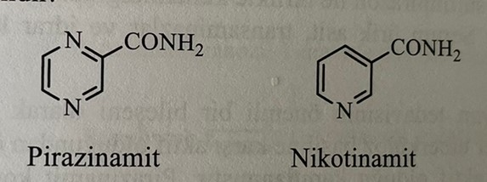
The preparation is obtained as a result of heating pyrazinedicarboxylic acid with urea.
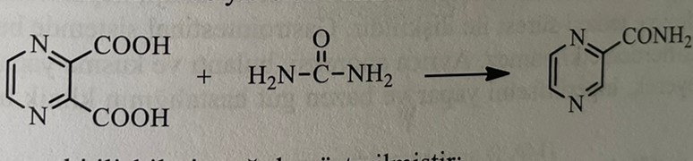
The structure-activity relationships established for pyrazinamide are as follows:
1) Almost all structural modifications of pyrazinamide are observed with a decrease in activity. Addition of an amine, hydroxyl, chlorine, or methyl group to the pyrazine ring results in decreased activity.
2) As a result of replacing the carboxamide group with an acid, complex ether, thionamide, nitrile or hydroxamic acid, a decrease in activity is observed.
3) Replacing the pyrazine ring with other heterocyclic rings (furan, thiophene, thiazole, pyrimidine) leads to a decrease in activity.
As a result of research conducted in recent years, new high-potential analogues have been synthesized. These analogues include tert-butyl-5-chloropyrazinamide and 2,-(2,-methyldecyl)-5-chloropyrazinamide.
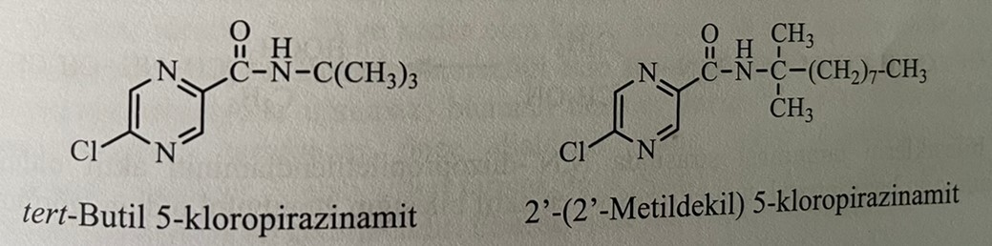
Pyrazinamide is a bactericidal drug. It is used against strains of M.tuberculosis resistant to streptomycin and isoniazid. Therefore, it is used in combination with isoniazid and rifampicin as the main drug. The activity of the compound depends on pH. Thus, it is effective in vivo at pH=5.5 and almost ineffective at neutral pH.
The mechanism of action of the compound is still unknown. Recent studies have identified pyrazinamide as a prodrug. Thus, mycobacteria have an enzyme called pyrazinamidase, which converts pyrazinamide into pyrazinic acid inside the cell. A mutation in the pyrazinamidase gene causes the appearance of resistant strains of mycobacteria. Pyrazic acid is biologically active at pH 5.5 or lower. Pyrazic acid causes a sharp decrease in the intracellular pH of mycobacteria. Protonated pyrazine acid penetrates through the membrane of mycobacteria and causes acidification of the cytoplasm. As a result of recent studies, it became known that pyrazine acid reduces the membrane potential of tubercle bacilli, reduces membrane transport and disrupts membrane energy.
Pyrazinamide is easily and well absorbed after oral administration. It spreads through tissues and body fluids. The maximum concentration in the plasma is reached after 2 hours. The elimination period is 10-16 hours. It is excreted from the body through the kidneys. It undergoes partial hydrolysis. Under the action of the microsomal liver enzyme pyrazinamidase, it turns into an active metabolite of pyrazinic acid. 30-40% of the dose is excreted in the urine in the form of pyrazine acid. The active metabolite reaches its maximum concentration approximately 6 hours after ingestion. The second metabolite is 5-hydroxypyrazinic acid, which is formed under the action of xanthine oxidase. 5-Hydroxypyrazine acid is excreted in free form or in the form of glycine conjugate with urine. It is believed that most of the compound is metabolized in the liver.
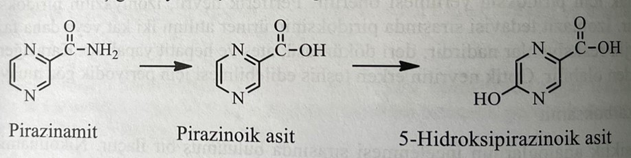
When combined with allopurinol, colchicine, probenezid or sulfinpyrazone, the concentration of acid in the plasma may increase, which may reduce the effectiveness of gout treatment. At the same time, the results of such analyzes as determination of uric acid in plasma, transaminases and ketones in urine may change.
Pyrazinamide is considered an important part of the combined therapy of tuberculosis. It shows maximum activity against the persistent strain of the tubercle bacillus. The duration of combined therapy with pyrazinamide decreased from six to nine months. The disadvantage of this compound when used orally is its high hepatotoxicity. Hepatotoxic effect occurs depending on the applied dose. Does not interact with food in the gastrointestinal tract and aluminum-magnesium antacids. At the same time, the drug can cause anorexia (lack of appetite), nausea and vomiting. The drug causes gout due to a decrease in the excretion of uric acid from the kidneys.
Morphonisamide: N-(morpholinomethyl)pyrazinecarboxamide
The drug is obtained by reacting pyrazinamide with morpholine and formaldehyde.
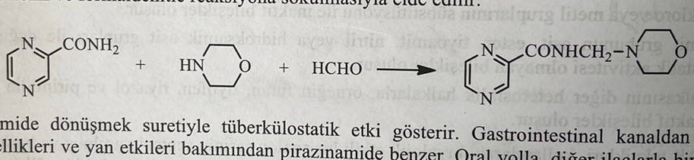
It acts by converting into pyrazinamide in the body. It is well absorbed from the gastrointestinal tract. It is a substance similar to pyrazinamide in terms of pharmacological and side effects.
Ethambutol: (+)-2,2,-(Ethylenediimino)di-1-butanol
Ethambutol is obtained by heating ethylenedichloride with (+)-2-aminobutanol.
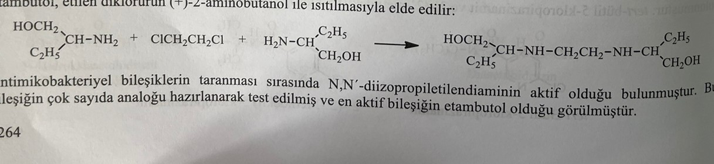
In the result of the study of antimicrobial compounds, it was noticed that N,N,-diisopropylethylenediamine is active. Many analogues of these compounds have been synthesized and tested. As a result, ethambutol turned out to be the most active compound. Elongation of the ethyldiamine chain in the molecule, replacement of one nitrogen atom by another, attachment of large functional groups to nitrogen atoms, replacement of alcohol groups lead to a decrease or disappearance of activity. The structure-activity relationship for ethambutol is as follows:
1) The right isomer of ethambutol is 200-500 times more active than the left isomer. The difference in activity between the two isomers indicates the presence of a specific receptor at the site of action.
2) Ethoxy-, methoxy- and methylamino derivatives show the activity of ethambutol in vitro.
3) The distance between nitrogen atoms must be preserved for maximum activity. When introducing atoms of carbon, oxygen or sulfur, the activity disappears.
4) Substitution of the alcohol functional group with amino, phenoxy- and thiol groups leads to a decrease in activity.
5) Replacing the dibutyl group with tertbutyl or hydroxyisopropyl group leads to a decrease in activity.
6) Adding a hydroxyl group to the third or fourth position of the double butyl radical leads to a decrease in activity.
The mechanism of action of ethambutol has not yet been clarified. The drug inhibits arabinosyltransferase, which catalyzes the polymerization of β-D-arabinofuranosyl-1-monophosphate, which is involved in the synthesis of the cell wall, into arabinogalactone (АГ) and lipoarabinomannan, which are polyarabisone compounds of the cell wall of mycobacteria. Ethambutol also reduces protein and DNA synthesis. Divalan forms a complex with cations and inhibits such amino acids as spermidine and spermine, which ensure the stability of nucleic acids.
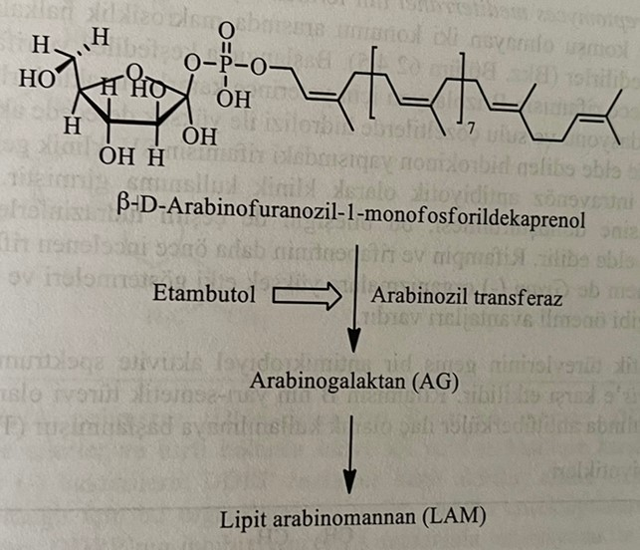
Ethambutol is a bacteriostatic drug used in addition to isoniazid and rifamine, which are bactericidal drugs in the treatment of tuberculosis. It is used in combination with isoniazid in mild forms of tuberculosis. In severe forms of tuberculosis, pyrazinamide and rifampicin are also used.
After ingestion, it is absorbed from the gastrointestinal tract by 75-80%. The maximum concentration in the blood is reached within 4 hours. Penetrating into the cells of erythrocytes, it shows the property of accumulating there. Most of the dose is excreted from the body with urine, and 20% with feces. Quick excretion through the kidneys. In patients with renal insufficiency, the dose of the drug should be reduced. The organism does not undergo significant biotransformation. 10-15% of the dose is first oxidized to dialdehyde, derivatives of dicarboxylic acid [2,2,-(ethylenediimino)dibutanoic acid] under the action of alcohol and aldehyde dehydrogenase enzymes in the liver. Metabolites are pharmacologically inactive. Its binding to plasma proteins is 40%. Bioavailability is about 80%. The elimination period is 3-4 hours.
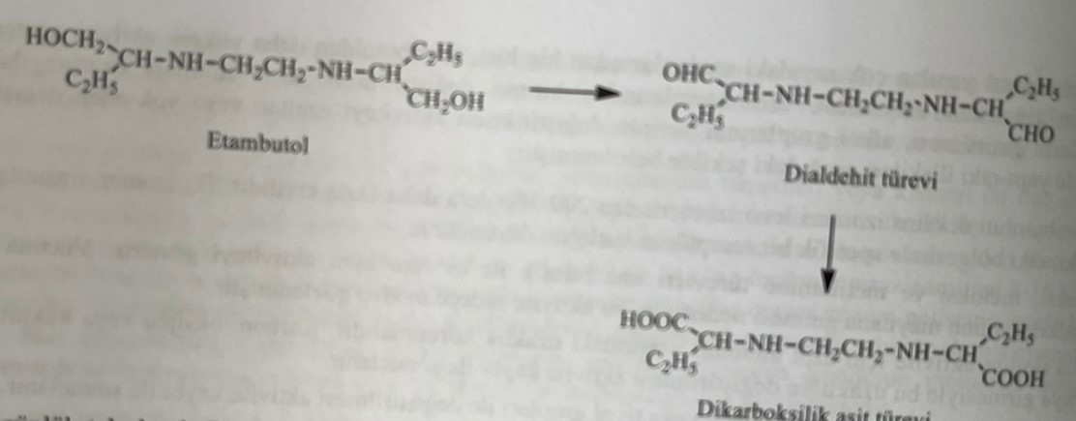
It is used orally as a single daily dose. It can be used in divided doses instead of single doses. Side effects of ethambutol are few and rare. Visual disturbances are mainly observed. Thus, the clear vision of shades of green and red flowers decreases. The use of the drug is contraindicated for patients with optic nerve damage. In rare cases, neuropathy, headache, allergy, arthralgia and hyperuremia can be observed. It does not have a teratogenic effect, so it can be used during pregnancy.
Rifampin (RIF)
Rifamycins are antibiotics isolated in 1957 from the fermented culture of Streptomyces mediterranei. It belongs to the group of antibiotics (ansamycins), which preserve a bridge with a macrocyclic ring between two non-adjacent positions of the aromatic ring. Only rifamycin B was isolated from the mixture, which was first discovered and named rifamycins A, B, C, D and E. But this compound is unstable and weakly active. As a result of oxidation and hydrolysis of rifamycin B in water, highly active rifamycin S is obtained. Rifamycin SV, obtained as a result of the reduction of rifamycin S and having the structure of hydroxynon, is the first rifamycin that entered clinical practice. It is used intravenously. Semisynthetic derivatives of rifamycins are obtained as a result of the transformation of rifamycins into 3-formylrifamycins and the subsequent interaction of these compounds with various hydrazines with the formation of rifampin and rifapentine. The fact that rifampin and rifapentin are suitable for oral application, that they affect both gram(+) and gram(-) bacteria, and that they have a clinical effect in the treatment of tuberculosis, are desirable features of these preparations.
Rifamycins and their semisynthetic derivatives have a wide spectrum of antimycobacterial activity. In particular, they show activity against gram(+) bacteria and M.tuberculosis. Rifampin, a semi-synthetic derivative of rifamycin B, which is well absorbed when taken orally, was used as an antimycobacterial drug in America in 1971.
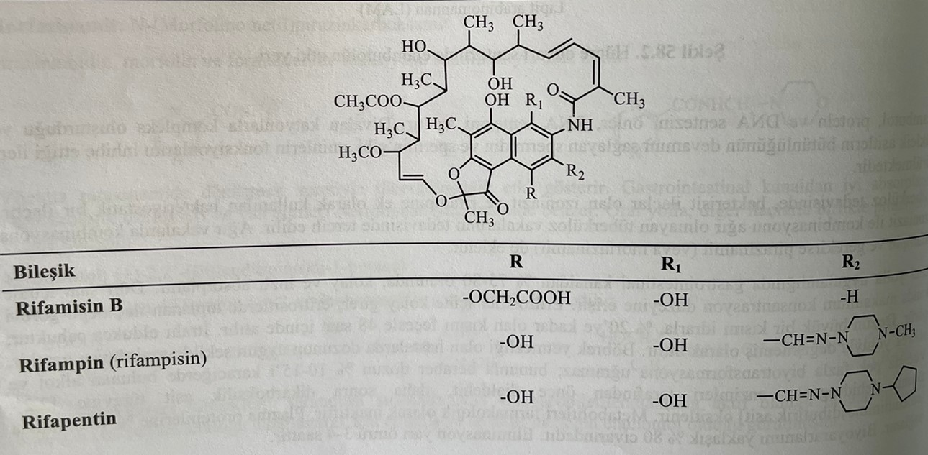
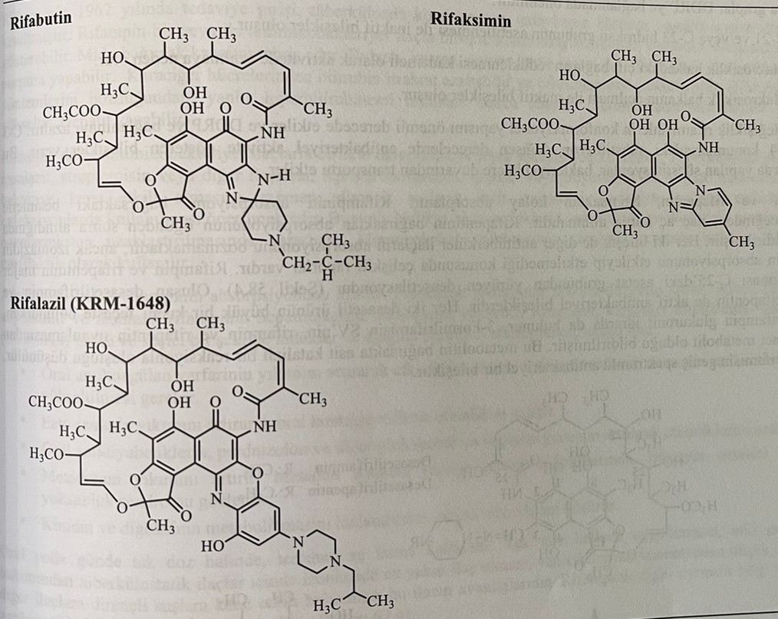
Rifamycins inhibit the enzyme DNA-dependent RNA polymerase (DDRP) by binding to the β-subgroup of the enzyme and have an antimycobacterial effect. Rifampicin is active against the DDRP enzyme of gram(+) and gram(-) bacteria. It has no activity against mammalian enzymes. Blockade of the DDRP enzyme leads to the cessation of RNA synthesis. Binding to the DDRP enzyme occurs through a π-π bond formed between the naphthalene ring of rifamycins and the aromatic amino acids of DDRP. DDRP is a metalloenzyme containing two zinc atoms. Chelation formed by zinc atoms of oxygen atoms connected to positions C-1 and C-8 of rifamycin increases binding to DDRP. At the same time, hydroxyl groups in positions C-21 and C-23 form strong hydrogen bonds with the enzyme DDPR. Mutations in DDPR lead to resistance to antibiotics.
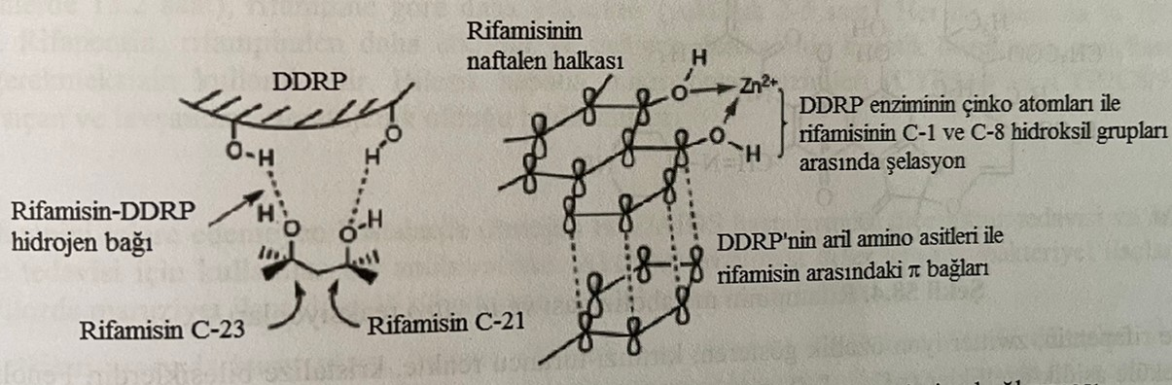
Vzaimosvyaz structure-activity relationship for rifamycins
1) The free hydroxyl group in positions C-1, C-8, C-21 and C-23 is important for activity. Hydroxyl groups in this position provide binding to DRPP.
2) As a result of acetylation of the hydroxyl group C-21 or C-23, inactive compounds are obtained.
3) Restoration of double bonds in the macrocyclic ring leads to a gradual decrease in activity.
4) As a result of the opening of the macrocyclic cycle, inactive compounds are obtained.
The last two changes affect the conformational structure of rifamycins and reduce binding to DDPR. Antibacterial preparations are obtained as a result of the addition of functional groups to positions C-3 or C-4. Changing these conditions leads to a decrease in bacteriotransport.
Rifampin and rifapentin are easily absorbed from the intestines. The drug should be used on an empty stomach, as the absorption of rifampin will decrease due to the action of nutrients in the intestines. Both compounds do not reduce the absorption of other antimycobacterial preparations. The main metabolism of rifampin and rifapentine occurs through the reaction of deacetylation of the acetyl group at the C-25 position. Active metabolites are desacetylrifampin and desacetylrifapentine. Desacetylrifapentine is excreted in the urine in the form of a glucuronide conjugate, although most of both deacetyl derivatives are excreted in the feces. It is considered that 3-formylrifamycin SV is a metabolite of rifampin and rifapentine. It is believed that these metabolites are formed as a result of a catalyzed acid reaction in the intestine. 3-formylrifamycin has a broad-spectrum antibacterial effect.
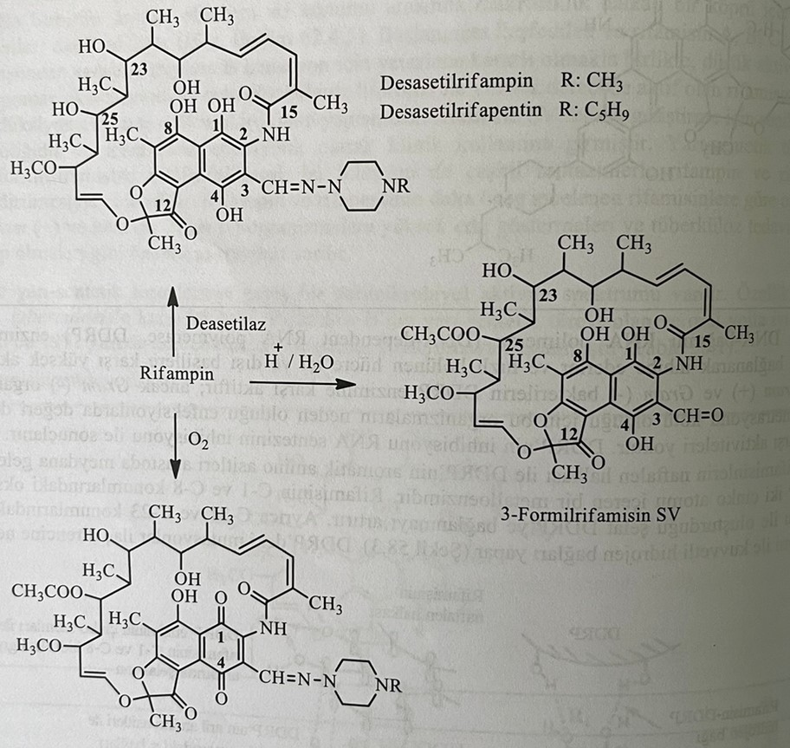
Rifampin and rifapentine have the properties of zwitter (hybrid) ions and are red-orange crystalline compounds. The presence of phenolic groups gives the molecule an acidic character (Pka=1.7), and the piperazine part gives it a basic character (pka=7.9). These compounds are prone to acid hydrolysis with the formation of 3-formylrifamycin SV. As a result of the oxidation of hydroxyl groups in the naphthalene ring of rifampin and rifapentine, p-quinone (С-1,4quinone) is formed in the air. Rifampin, rifapentin and its metabolites are excreted from the body with urine, feces (biliary tract), saliva, sweat and tears. Since these compounds have coloring properties, staining is observed in body fluids. A certain amount of tears can be stained, and a stain is visible on worn artificial lenses.
Rifampin was introduced to treatment in 1967. and allowed to shorten the duration of combined tuberculosis therapy from 18 to 9 months. Rifampin is used in combination with one or two antimycobacterial drugs. May have a hepatotoxic effect. This can cause infection in the gastrointestinal tract. Nausea, vomiting, abdominal pain, rash and thrombocytopenia are observed. Violation of bilirubin metabolism in the liver causes bilirubinemia. Raises the level of plasma transaminases (ALT, AST, ЩФ) and causes hepatitis.
Rifampicin is used in combination with other antimycobacterial drugs for the treatment of tuberculosis and leprosy. It is used in combination with ethambutol, isoniazid, streptomycin and other drugs for tuberculosis, as well as in combination with clofazimine, dapsone or ethionamide for leprosy. To prevent the frequent occurrence of resistance in bacteria, this drug is used only for mycobacterial infections. At the same time, it is used in the treatment of acute endocarditis and against Neisseria meningitidis. It is used for prophylactic purposes in people who have been in contact with meningococcal infection.
Aminosalicylates reduce the absorption of rifampin. Probenazid increases the concentration of rifampin in blood plasma. Alcohol, disulfiram, ethionamide and isoniazid increase the hepatotoxic effect of rifampin. Rifampicin strongly and selectively induces microsomal liver enzymes (CYP3A4) and causes the following interactions:
1) Increases the breakdown of warfarin, an oral anticoagulant, and reduces its effect. During treatment with rifampicin, the dose of warfarin should be increased.
2) Reduces the effect of oral contraceptives due to the increase in the breakdown of estrogens.
3) Reduces the effect of oral antidiabetic drugs, prednisolone and other glucocorticoid drugs due to their increased breakdown.
4) Increases the splitting of methadone. Withdrawal syndrome caused by rifampicin develops in opioid addiction treated with methadone.
It is used orally in a single dose. It is recommended to use the drug on an empty stomach.
rifapentine
Rifapentin is the first and new compound developed for the treatment of tuberculosis in the last 25 years. The advantage of the combination over rifampin is that it is used twice a week. When taken orally, rifapentin is easily absorbed and binds to plasma proteins (97%). As a result of binding to plasma proteins, the half-life of rifapentine is higher than that of rifampin. More than 70% of both preparations are excreted with feces. Rifapentine is more effective than rifampicin. The compound induces microsomal liver enzymes (CYP3A4 and CYP2C8/9). In vivo studies conducted on mice and rabbits have shown that rifapentine has a teratogenic effect.
Rifabutin
Rifabutin is used for tuberculosis that does not respond to rifampin treatment. At the same time, this is an effective drug against M.avium infection. It is used in combination with other antimycobacterial preparations for active tuberculosis. The most frequently observed side effects are abdominal pain, nausea, rash, headache and low level of neutrophils. At the same time, myalgia and uveitis are observed. Despite the fact that harmful effects during pregnancy were not observed, population studies were not conducted. This drug, approved in America in 1992, is considered the main anti-tuberculosis drug.
Rifaximin
Rifaximin is used orally in the treatment of traveler's diarrhea and hepatic encephalopathy. It is also considered an effective drug for irritable bowel syndrome. Relatively poor absorption makes the drug stay in the gastrointestinal tract for a long time.
Rifalazil
Rifalazil is used to treat diarrhea associated with tuberculosis, Chlamydia infections, and Clostridium difficile. It is considered an effective drug in the treatment of tuberculosis due to its good penetration into blood cells and lungs. Since the elimination half-life is long, it is used in a single dose. Although it is very effective in tuberculosis, side effects are observed during its use. The compound was removed from the registry in 2013 due to its many side effects.
Streptomycin
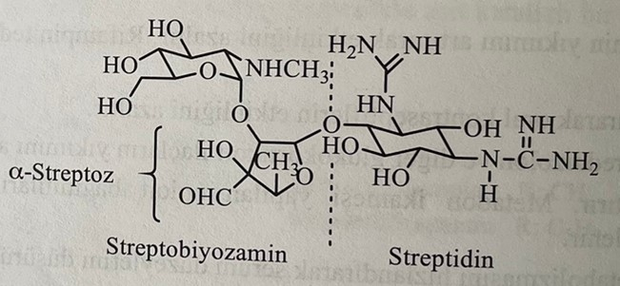
Streptomycin, which is considered a secondary drug in some literature, is the first biologically active aminoglycoside obtained from Streptomyces griseus in 1944 by Waksman and his colleagues. Its chemical structure was clarified in 1948. It has antimicrobial action against gram(+) and gram(-) bacteria, including M.tuberculosis. For the first time, it was used independently and in high doses in the treatment of tuberculosis. Then the development of bacterial resistance to the drug and the appearance of toxic effects were not observed. With the discovery of other compounds, this drug began to be used in combination, and bacterial resistance and toxic effects were reduced to a minimum.
The compound is made in the form of a salt of trihydrochloride or one and a half sulfate. Both salts are well soluble in water. Since this is a hydrophilic drug, it is poorly absorbed from the gastrointestinal tract. When used orally, most of the drug is excreted with feces, no biological action is observed.
Although all aminoglycosides have similar pharmacological, pharmacodynamic and toxic effects, streptomycin, kanamycin and amikacin are used in the treatment of tuberculosis. The structure-activity relationship for streptomycin is as follows:
1) The structure of the streptococcal ring of streptomycin has changed. For example, dihydrostreptomycin was obtained by the reduction of an aldehyde group to a primary alcohol group. This compound has an effect equivalent to streptomycin. Its toxic effect on the vestibular system is greater than that of streptomycin, and it causes hearing impairment.
2) Oxidation of aldehyde group to carboxyl group leads to loss of activity. The conversion of the aldehyde group into oxime, semicarbazone and phenylhydrazone also leads to loss of activity.
3) Oxidation of the methyl group in the structure of α-streptosan to hydroxymethylene leads to the formation of an analogue with weaker activity than streptomycin.
4) Demethylation of the aminomethyl group in the glucosamine part of the molecule or replacement with larger alkyl groups reduces activity.
5) Removal or modification of the guanidine group in the streptid nucleus leads to a decrease in activity.
The mechanism of action of streptomycin and aminoglycoside antibiotics has not been fully clarified. The antibacterial effect occurs as a result of joining the 16S group to the bacterial 30S ribosomal subgroup. As a result of this irreversible interaction, the biosynthesis of bacterial proteins is inhibited and abnormal proteins are formed. Abnormal proteins formed at the same time are not essential for the bactericidal effect. Streptomycin inhibits enzymatic polymerization of amino acids. This is what provides the bactericidal effect.
Absorption of streptomycin when taken orally is 1%. It is stable in the gastrointestinal tract and is excreted unchanged in feces. It is quickly absorbed after subcutaneous or intramuscular administration. The maximum concentration in plasma is reached after 30-90 minutes. The elimination period is 2-3 hours.
Metabolites are not detected in the urine of patients receiving streptomycin. 50-60% of the drug is excreted unchanged in the urine. The development of resistant strains of M.tuberculosis is a deficiency of treatment with streptomycin. Combined therapy partially solves this problem, but resistance reduces the importance of streptomycin in the treatment of tuberculosis. The mechanism of resistance of M.tuberculosis is explained by different reasons. Permeability barriers can prevent the transport of streptomycin through the cytoplasmic membrane. Enzymatic inactivation of streptomycin is also considered a big problem. Enzymes that cause inactivation are adenyltransferase, which catalyzes the adenylation of the C-3 hydroxyl group in N-methylglucosamine with the formation of an O-3-adenylated metabolite, and phosphorylase, which phosphorylates the same C-3 hydroxyl group with the formation of O-3-phosphorylate. . The second reaction is clinically very important. Metabolites formed during these chemical transformations do not have the ability to bind to ribosomes.
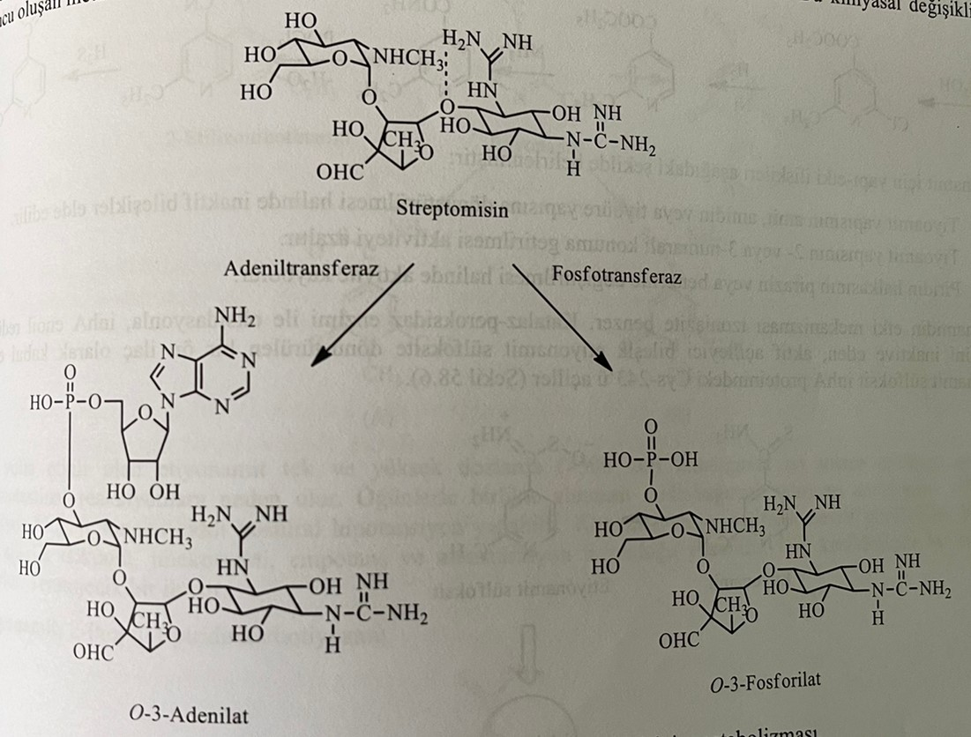
Streptomycin is used intramuscularly in the treatment of tuberculosis. It is used in combination with isoniazid. Ethambutol strengthens the action of oral preparations, such as isoniazid. It is used for bacterial endocarditis, brucellosis, tularemia and urinary tract infections. Strengthens the neuromuscular blocking effect of curare-like substances, the toxic effect of other ototoxic (ethacrynic acid, furosemide) or nephrotoxic (cephalosporins, polymyxins) preparations.
Side effects of streptomycin can also occur depending on the dose. Vestibular disorders may occur as a result of long-term use of high doses. Signs of ototoxicity were observed in children born to women who received streptomycin during pregnancy.

Secondary drugs
Ethionamide: 2-ethyl-4-pyridinecarbothioamide
The action of nicotinamide against tuberculosis was established in 1945. However, the use of this drug is limited due to its anti-tuberculosis action in high doses. Ethionamide, isoniazid, and pyrazinamide are active compounds among nicotinamide analogs.
In the synthesis of ethionamide, 2-ethyl-4-carboxy-6-pyridone is obtained by reacting 2-ethyl-4-carbethoxy-5-cyano-6-pyridone with hydrochloric acid, which is formed as a result of the condensation of ethylpropionylpyruvic acid with cyanoacetamide. When this compound interacts with the mixture of oxychloride and phosphorus pentachloride, a dichloroproduct is formed. Catalytic dehalogenation occurs when dichlorproizvodnogo reacts with ethanol and 2-ethylisonicotinate is obtained. The reaction of this compound with ammonia gives 2-ethylisonicotinamide. Then the reaction of dehydrogenation with phosphorus oxychloride occurs and a nitrile derivative is formed. Ethionamide is obtained by reaction of derivative nitrile with hydrogen sulfide in triethanolamine.
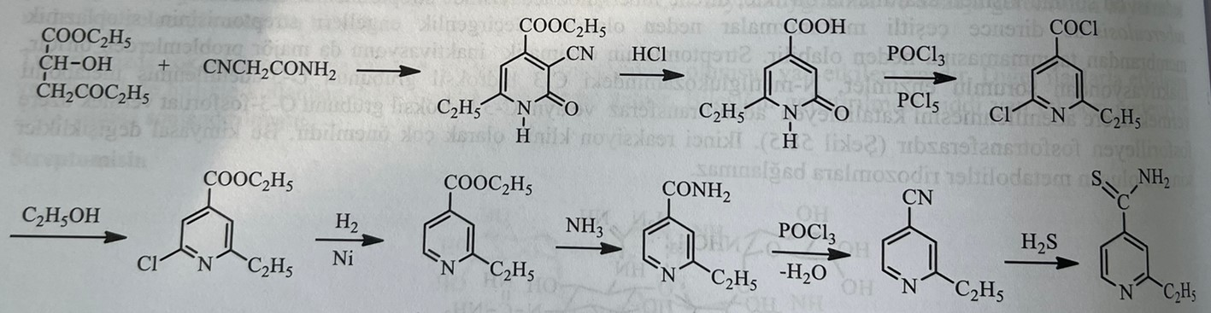
The structure-activity relationships for ethionamine are as follows:
1) As a result of conversion of thioamide structure to amide, amide and thiourea structure, inactive compounds are formed.
2) Bringing the thioamide structure to the 2nd or 3rd states causes a decrease in activity.
3) Substitution of pyridine ring with pyrazine or benzene leads to loss of activity.
The mechanism of action of ethionamide is similar to isoniazid. The drug is a prodrug that inhibits the enzyme inhA enoyl reductase by being oxidized by the catalase-peroxidase enzyme and turns into ethionamide sulfoxide, an active alkylating compound. Ethionamide sulfoxide acylates Cys-243 in the inhA protein.
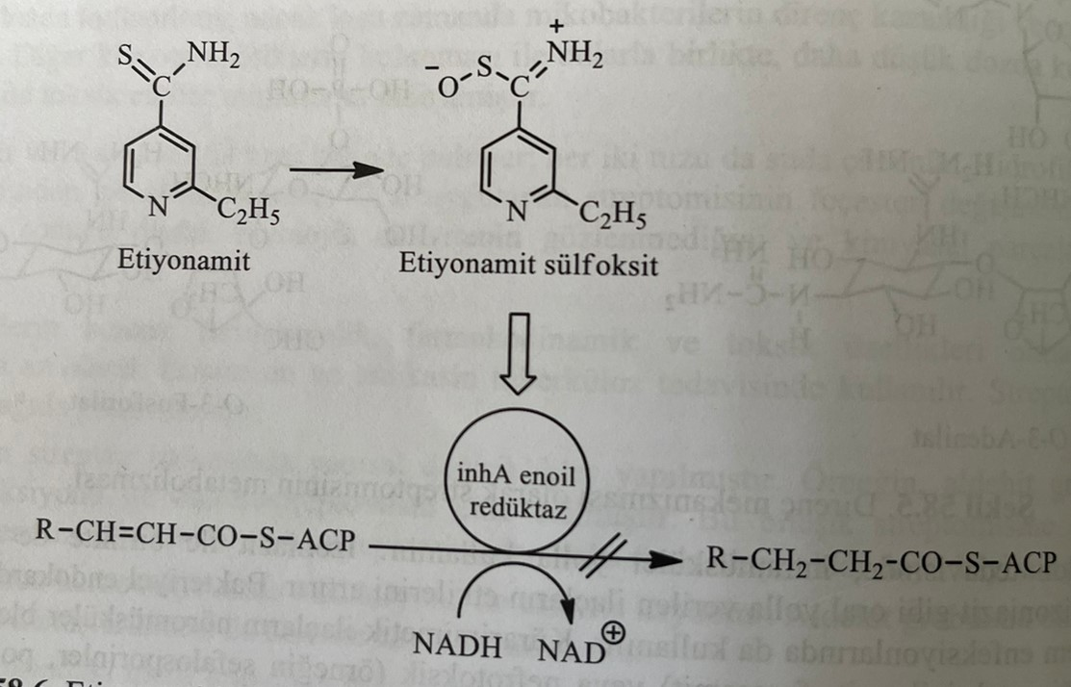
The activity of ethionamid is equivalent to 10% of the activity of isoniazid. Its toxicity is higher than that of isoniazid. Due to the emergence of bacterial resistance soon after its application, the drug is prescribed in combination with other antimycobacterial drugs. At the same time, it is used in the treatment of leprosy. Since the drug acts as an antagonist of pyridoxine (increases the renal excretion of vitamin B6), it causes peripheral neuritis. Therefore, patients receiving ethionamide should be prescribed supplements with vitamin B6.
It is quickly and completely absorbed from the gastrointestinal tract. After absorption, it penetrates into many tissues, as well as into the cerebrospinal fluid and all body fluids. The maximum concentration in the plasma is reached approximately 3 hours after ingestion. In the liver, active metabolites such as ethionamidesulfoxide, 2-ethylisonicotinamide and N-methyl-6-oxodihydropyridines (А, В and С) turn into inactive metabolites. It is excreted in the urine. The amount of the unchanged drug in the urine is 1%, and the amount of the active metabolite is 5%. The biological period of elimination is 2-4 hours.
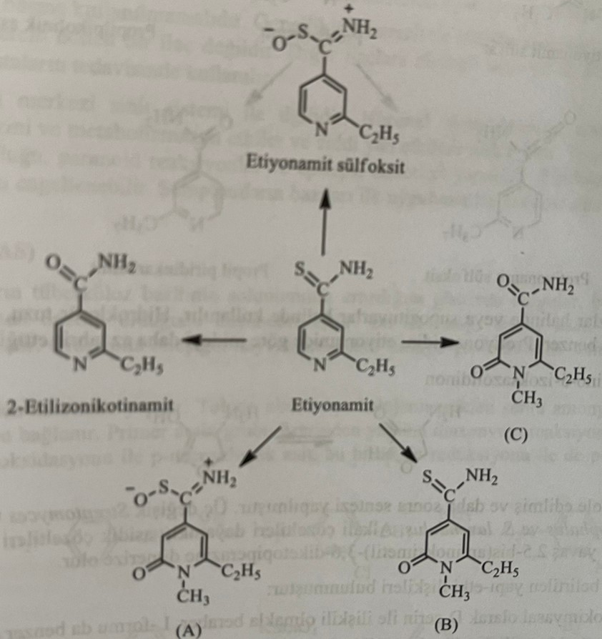
Ethionamide, which is active orally, is used in single doses and in high doses. Causes serious gastrointestinal reactions. Taking it with food causes poisoning in the gastrointestinal tract. As a result of autonomic ganglia blockade, severe pastural hypotension may develop. It causes convulsions and peripheral neuritis. Side effects such as hepatitis, allergic reactions, gynecomastia, impotence and menstrual disorders are observed. These effects disappear when the drug is stopped. It has a teratogenic effect.
Prothionamide: 2-Propyl-4-pyridinecarbothionamide
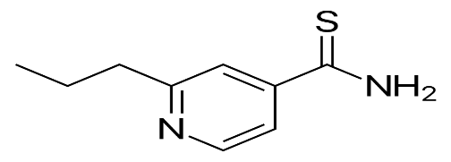
The synthesis of protionamida is analogous to the synthesis of ethionamida. Ethylbutyrylpyruvic acid is used instead of propionylpyruvic acid as a starting material.
This is a bacteriostatic drug that has a bactericidal effect in large doses. When developing resistance to the main drugs, they are used in combination with other anti-tuberculosis drugs. It is also used in the treatment of leprosy.
It is quickly and completely absorbed from the gastrointestinal tract. It easily penetrates the liquid and tissues of the body. Cerebrospinal fluid also drains easily. The maximum concentration in the plasma is reached after 2-3 hours after application. The biological period of elimination is 2-4 hours. He has a slow metabolism. It is excreted in the urine. During biotransformation, reactions of disulfide, oxidative deamination, and sulfate conjugation occur in protionamides. It is established that prothionamide sulfoxide has an antimycobacterial effect in vitro.
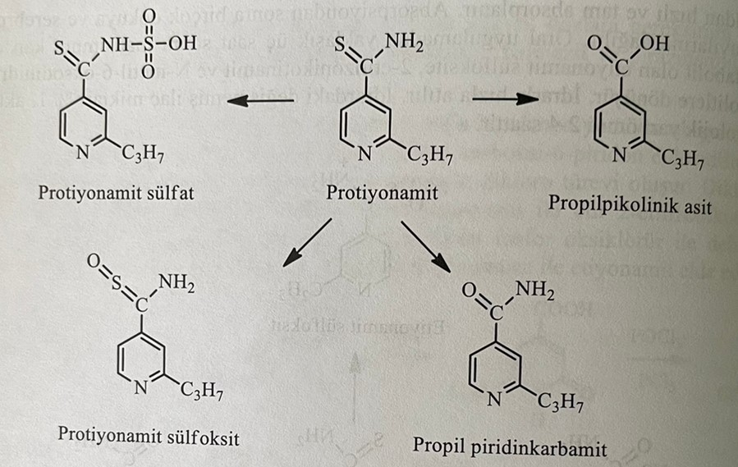
It is used in forms suitable for oral use and in the form of suppositories for rectal use. It is used intravenously in the form of a hydrochloride salt. Side effects are similar to ethionamide. Prothionamide has been found to cause fewer gastrointestinal reactions than ethionamide.
Cycloserine: D-(+)-4-Amino-3-isoxazolidinone
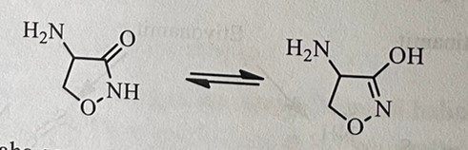
It was first isolated in 1955, and later a synthesis method was developed. It was isolated from three different species of Streptomyces (S.orchidaceus, S.garyphalus and S.lavendulus). Basic solutions are stable, and acidic solutions are unstable. In solution, it slowly dimerizes to 2,5-bis(aminooxymethyl)-3,6-diketopiperazine.
The structure-activity relationship for cycloserine is as follows:
1) Although cycloserine is stereochemically related to D-serine, the L-form also exhibits similar activity.
2) 3-isoxazolidone, formed as a result of amino group removal, is an inactive compound. On the contrary, 4-aminooxyproizvodnoe has an active antimycobacterial effect.
Cycloserine shows its antibacterial effect, preventing the synthesis of cross-linked proteins during the formation of the cell wall of bacteria. During the synthesis of the cell wall, L-alanine turns into D-alanine, after which two molecules of D-alanine combine. Both reactions are inhibited by cycloserine, an analog of D-alanine.
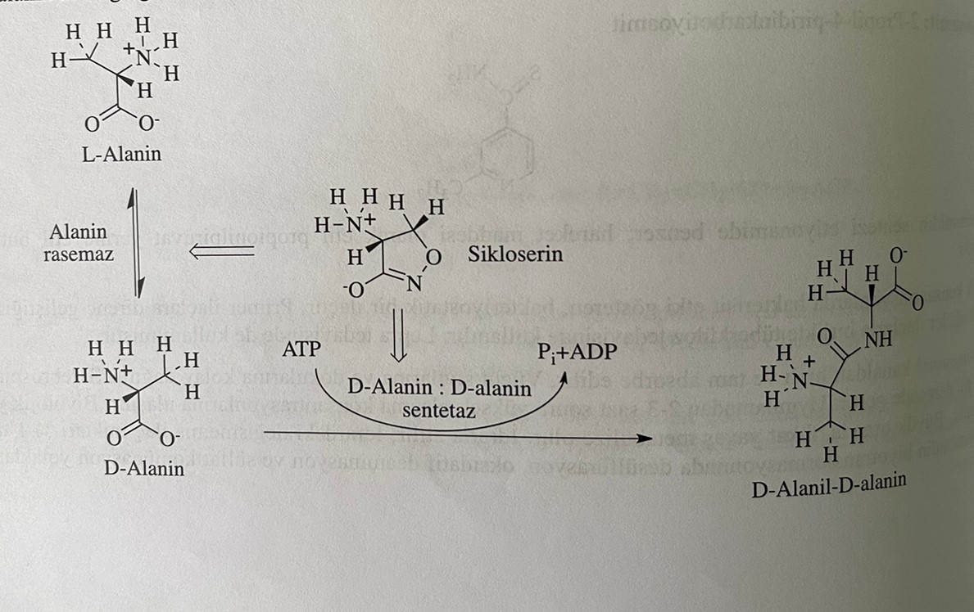
This is a broad-spectrum antibiotic. Despite its in vitro activity against gram(+) and gram(-) bacteria, it is used only in the treatment of tuberculosis, as it causes toxic reactions. It does not have an antimycobacterial effect on mice infected with M. Tuberculosis. This is due to the fact that the drug is quickly removed from the body of mice.
After ingestion, it is quickly and completely absorbed from the gastrointestinal tract. The maximum concentration in the plasma is reached after 3-4 hours after application. This is the smallest molecule of the tuberculostatic drug. It easily diffuses through the biological membrane. It has the ability to penetrate many tissues, including the central nervous system. After 72 hours, 65% is excreted unchanged by the kidneys. Accumulation of the drug in the body is observed in renal failure.
It is used orally. It should not be used alone. It is mainly used in combination with isoniazid. Its use is limited due to multiple side effects. Side effects of cycloserine are related to the central nervous system. Binding to neuronal receptors of N-methylaspartate, it affects the synthesis and metabolism of γ-amino acids. Side effects such as tremors, headaches, confusion, depression, visual disturbances, paranoid reactions and epileptic seizures are observed. Side effects weaken when combined with pyridoxine. Some symptoms appear shortly after the first use, and side effects disappear when the drug is stopped.
p-Aminsalicylic acid (PASK)
The influence of benzoate and salicylates on the metabolic processes of mycobacteria has been studied for a long time. During these studies, PAS was opened. As a result of experiments on animals, it was established that PAS is an active compound when administered orally, and clinical studies were started.
For the synthesis of the compound, toluene is used as the starting material. After nitration and halogenation of toluene, the resulting compound is treated with ammonia and a primary amino group is added. p-nitrosalicylic acid is formed during the oxidation of 2-hydroxy-4-nitrotoluene, obtained as a result of the introduction of the primary amino group into the diazonium reaction. PAS is obtained by restoring this connection.
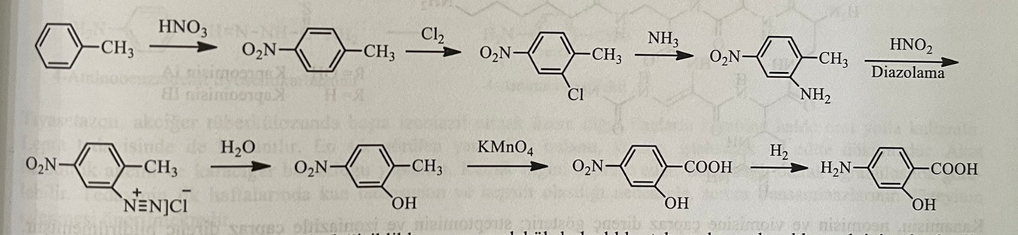
Structure-activity relationships for PAS are as follows:
1) Inactive compounds are obtained as a result of the transformation of the primary amino group into a hydroxyl, alkyl, ternary amino or amide structure. The para-amino group provides activity and must be free.
2) The hydroxyl group is located in the o- or m-position relative to the carboxyl group. However, optimal activity is observed in the ortho state. The loss of activity occurs if the hydroxyl group is transformed into the structure of a simple or complex ether and instead of the hydroxyl group, thiol and amino groups are included in the molecule.
3) Activity is lost when the carboxyl group turns into an alkyl ether, amide, amide or nitrite. Activity is observed in phenyl ethers. Because it can become a free acid.
4) In the form of calcium salt, the anti-inflammatory effect of the drug in the gastrointestinal tract decreases.
The mechanism of antibacterial action of p-aminosalicylic acid is analogous to the action of sulfonamides. Thus, it inhibits the enzyme dihydrofolate synthetase, which catalyzes the combination of p-aminobenzoic acid with dihydrofolic acid.
This is a bacteriostatic drug. PASK is used in combination with isoniazid and streptomycin. It is mainly used orally in the form of tablets or capsules. Enteric-soluble closed dosage forms are used to avoid the tanning effect of acid or sodium salt. It is also combined with calcium salt, phenyl ether and anion exchange resin (resi-PAS) to reduce the vaccination effect.
Absorption of p-aminosalicylic acid when taken orally is fast and complete. The maximum concentration in the plasma is reached approximately after 2 hours. Blood parameters return to normal after 4-5 hours. It penetrates well into all body fluids, except cerebrospinal fluid. In urine, it is found in unchanged form and in the form of metabolites. It is metabolized by means of reactions of acetylation of the amino group and conjugation of the carboxyl group with glucuronic acid and glycine.
When used in a normal dose, a large amount of metabolite N-acetyl is found in the urine, and, as in the case of acetylated sulfonamides, its compounds are difficult to dissolve in the urine. Urine is alkalized to prevent crystalluria. Using sodium salt eliminates this problem. When combined with isoniazid, acetylation of isoniazid decreases. Therefore, the concentration of isoniazid in plasma increases. The biological period of elimination of p-aminosalicylic acid is 2 hours.
In certain doses, it causes anorexia and nausea. Calcium salt is used to reduce this effect. This can also cause fever and joint pain. Allergic reactions may develop in 5-10% of patients. p-aminosalicylic acid causes metabolic acidosis. Sodium salt is used to prevent metabolic acidosis.
Capreomycin
Capreomycin is a cyclic polypeptide antibiotic, similar in its physical and chemical properties to viomycin. It was isolated from Streptomyces capreolus in 1960. In 1971, it was recognized as an anti-tuberculosis agent in the United States. Capreomycin, secondary preparation, is used in cases where the patient is sensitive to streptomycin, and M.tuberculosis is resistant to streptomycin. Four types of capreomycin, IA, IB, IIA and IIB, were isolated from S. capreolus. In clinical practice, drugs IA and IB are used in the form of a sulfate salt. Sulfuric salt is well soluble in water.
The mechanism of action consists in inhibiting the synthesis of bacterial protein by preventing the elongation of the bacterial protein chain, as in viomycin.
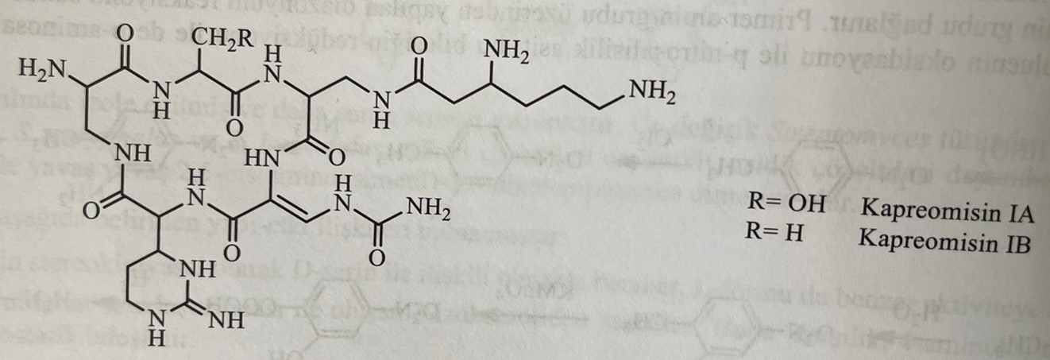
Due to the emergence of bacterial resistance to the preparation, it is not used alone. The drug is prescribed in combination with PAS, isoniazid and ethambutol. Water solubility makes it easy to use. It is excreted from the body unchanged with urine without undergoing metabolism. The most common side effects are kidney and liver damage. It causes hearing impairment, proteinuria and nitrogen retention.
Thiacetazone: N-[4-[[(Aminothioxomethyl)hydrazono]methylene]phenyl]acetamide
It is a tuberculostatic drug that is a derivative of thiosemicarbazone. During the study of the intermediate products formed during the synthesis of sulfathiadiazoles, it was determined that benzaldehyde thiosemicarbazone is an effective substance in tuberculosis, and a 4-acetamido derivative was obtained by changing the structure.
Thiacetazone is formed by acetylation of the intermediate product obtained by the reaction of 4-aminobenzaldehyde with thiosemicarbazide with acetic anhydride.
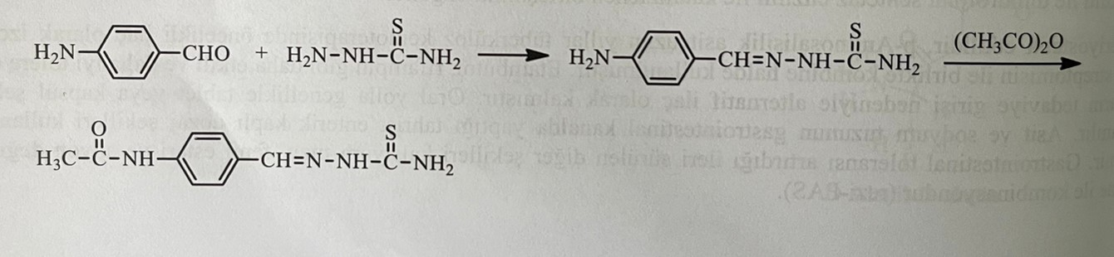
The relationship between the structure and activity of thiacetazone and its derivatives is as follows.
1) As a result of replacing the thiosemicarbazone group with a semicarbazone, hydrazone or oxime group, inactive compounds are obtained.
2) Addition of one or two alkyl groups to the single amino group of the thiosemicarbazone structure or replacement of the sulfur atom with oxygen or nitrogen atoms leads to a decrease in activity.
3) the order of activity of radicals attached to the para-position is as follows: (CH3)2CHNH > NH2=CH3CONH=(CH3)2N>NO2
The mechanism of action is not exactly known. It is believed that it acts by preventing the synthesis of mycolic acid. Studies have shown that thiosemicarbazone derivatives are not competitive inhibitors of p-aminobenzoic acid. Does not form cross-resistance with isoniazid. It can also be used to prevent resistance to potent drugs such as isoniazid and rifampicin.
As a result of thiacetazone poisoning and the introduction of effective compounds such as isoniazid into the clinic, the use of this drug was limited. At the same time, the action against tuberculosis mycobacteria is weaker than that of other preparations.
When taken orally, it is well absorbed from the gastrointestinal tract. The maximum concentration in the plasma is reached 4 hours after the reception. Most of the dose undergoes biotransformation and is excreted from the body with urine in approximately 48 hours. The main products of biotransformation are thiosemicarbazone 4-aminobenzaldehyde, 4-acetylaminobenzaldehyde, 4-aminobenzaldehyde and 4-acetylaminobenzoic acid.
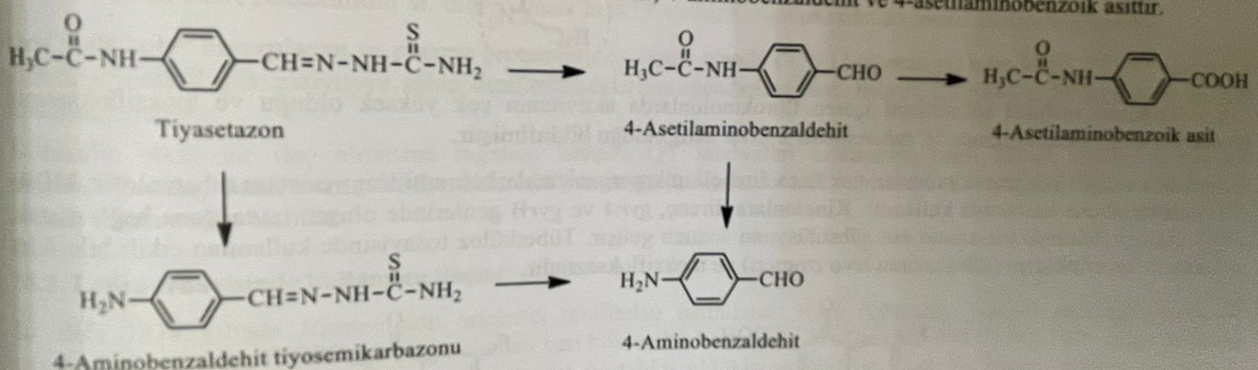
Thiacetazone is prescribed in combination with isoniazid in pulmonary tuberculosis. The most common side effects are nausea, vomiting, loss of appetite, and diarrhea. It is also used in the treatment of leprosy. There is a risk of causing acute hemolytic anemia and hepatitis. At the same time, the drug causes depression of bone marrow cells, which causes agranulocytosis and various types of anemia.
Fluoroquinolones
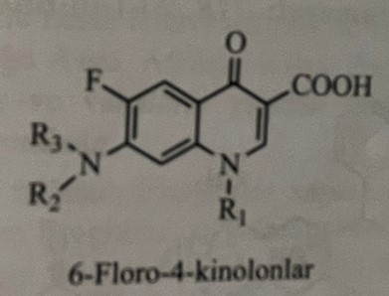
Fluoroquinolones are antibacterial preparations with a wide spectrum of action. It is susceptible to infections by M. Tuberculosis, M. kansaii, M. xenopi, M. fortuitum and M. avium, as well as many gram (+) and gram (-) pathogenic bacteria, including M. leprae. Due to their effectiveness at low concentrations and fewer side effects, they are very attractive drugs. The drugs bind to the DNA-gyrase-DNA complex (Gyr A and Gyr B) and inhibit the replication and transcription of bacterial DNA.
Structure-activity relationships were studied for the specified action against Mycobacterium and the M.avium complex. Quinolones, which do not have a fluorine atom, are more sensitive to mycobacteria. It is established that some compounds in the structure of quinolones strengthen (biophores) and, on the contrary, weaken (biophobes) activity against MAC. Structural changes introduced for the effect of biophore include the cyclopropyl ring in the N-1 position, fluorine atoms in the C-6 and C-8 positions, and the heterocyclic ring in the C-7 position. Extreme lipophilicity in position N-1 (for example, 2,4-difluorobenzene) reduces activity. In compounds showing high activity against mycobacteria, piperazine and pyrrolidine are combined in C-7 positions.
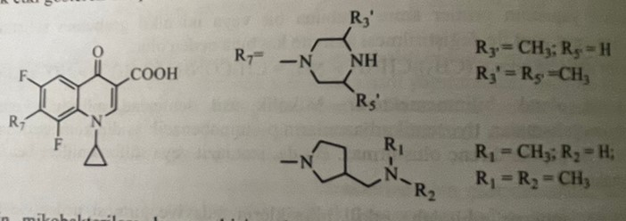
Although 4-quinoline derivatives are ineffective against mycobacteria, their structures are shown below.
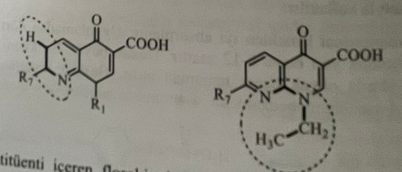
In the case of C-8, the activity of fluoroquinolones with a methoxy group was very high, and the activity against tuberculosis bacilli was observed when moxifloxacin was combined with isoniazid.
In the treatment of tuberculosis, fluoroquinolones are prescribed only when the bacteria become resistant to antimycobacterial drugs. Bacterial resistance to quinolones is possible as a result of mutation of genes gyr A and gyr B. Ofloxacin, levofloxacin and moxifloxacin are mainly used in the treatment of tuberculosis.
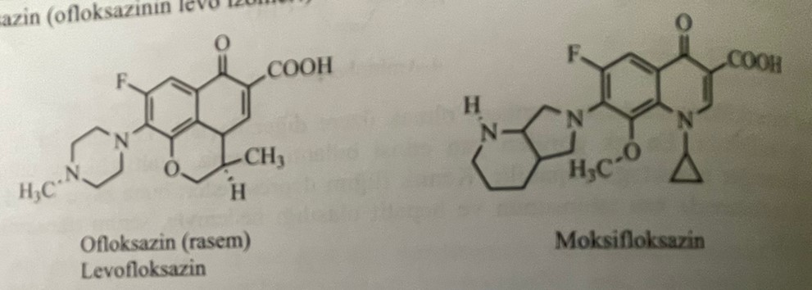
Newly approved drug: Bedaculine fumarate : (1R,2S)-1-(6-bromo-2-methoxyquinolin-3-yl)-4-dimethylamino-2-(naphthalen-1-yl)-1-phenylbutan-2-ol - fumarate.
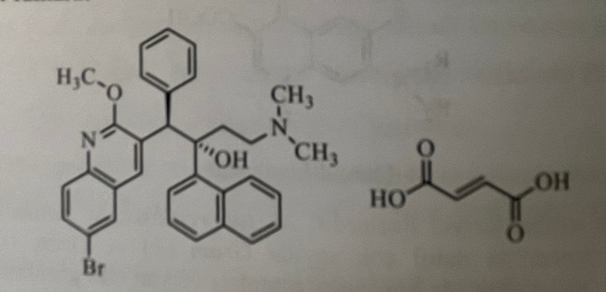
Bedaculine fumarate, a diaryl quinoline derivative, has been used in the treatment of tuberculosis for more than 40 years. It is not a suitable drug for single treatment. Therefore, the drug is used in combination with other drugs. The mechanism of action of the compound is blocking the ATF synthase C subunit bound to the cell membrane of tuberculosis bacilli. It prevents the conformational change of the synthase enzyme. It disrupts the proton exchange necessary for the production of ATF by bacteria. The critical structural features for ATF synthase C subunit binding to amino acids are triplet amine, triplet alcohol, halide, and ether oxygen.
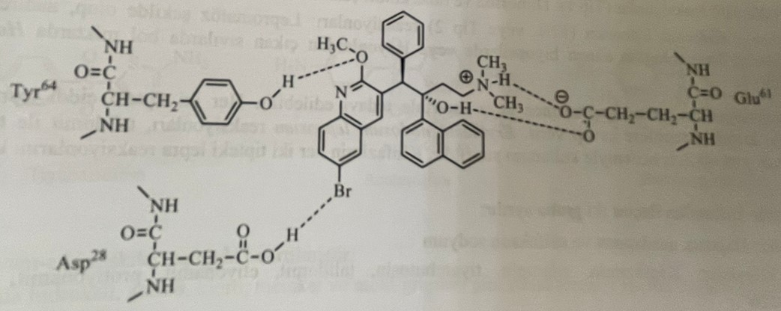
It is well absorbed when taken orally and has maximum binding to plasma proteins. The compound undergoes demethylation by the enzyme CYP3A4 and is metabolized to desmethylbeducalin with low activity. Although bedaculin is an effective drug, it causes prolongation of the QT interval in patients. This potential is very dangerous, and the prescription of the drug should be limited unless it is absolutely necessary.
Drugs used in the treatment of leprosy.
Leprosy, which was first investigated by a researcher named Hansen in 1874, is also known as Hansen's disease. Leprosy is a disease that has existed since ancient times. It was especially widely spread in Europe in 1400. People infected with the disease were isolated from society, wearing special clothes only because they were sick. Currently, leprosy is a chronic infectious disease with low infectious potential and weak development at the beginning, but in the later stages it causes deformations and injuries (loss of various organs).
The causative agent of human leprosy is Myocobacterium laprae, also known as Hansen's bacillus. Reproduction of leprosy bacilli lasts about 1 month, but the incubation period of these bacilli in humans is 3-5 years. The disease spreads through the upper respiratory tract. Since 1980, sixteen million people have undergone treatment. In 2016, India was the number one country for leprosy with more than 214,000 active patients. At the same time, Brazil and Indonesia are among the countries with a high risk of spreading.
There are 4 types of leprosy.
1) Indeterminate leprosy
2) Tuberculoid leprosy
3) Lepramatous leprosy
4) Dimorphic leprosy
Indeterminate leprosy is the most easily diagnosed type of leprosy. Its main symptoms are hypopigmentation and loss of certain sensations. These types of symptoms pass by themselves after some time. In the absence of treatment, tuberculoid leprosy or lepramatous leprosy develops. With tuberculoid leprosy, colorless spots are observed on the skin, and at this time, mycobacteria begin to accumulate in the nerves. Accumulation of mycobacteria in the nerves creates an anesthetic effect, which leads to a complete loss of skin sensitivity. The lepramine test, consisting of a suspension of sterilized tissue rich in M. Leprae, gives a positive reaction to lepramine. Lepramatous leprosy is the most dangerous type of leprosy. With this disease, the skin is thickened, shiny and wrinkled. At the same time, the skin and muscles atrophy, the nerves are completely damaged, and the bones near the affected areas quickly resorb.
Leprosy and leprosy reactions are very difficult to treat. Because these reactions require specific treatment. Reactions usually go two ways.
1) Reversible reactions
2) Reactions of erythema nodosum leprosy
Mild reactions of leprosy are treated with aspirin. Corticosteroids, such as prednisolone, can be used in the development of leprosy reactions. Erythema nodosum leprosy is treated with thalidomide, but the introduction of thalidomide to pregnant women causes teratogenic effects. Thus, this drug, used in the first trimester of pregnancy, overcomes the double barrier and has a negative effect on the development of the uterus, as a result of which the thalidomide tragedy develops. During the thalidomide tragedy, children were born without arms and legs.
The drugs used in the treatment of leprosy are divided into two groups.
1) Sulfone: dapsone, acedapson and sulfoxone sodium
2) Other compounds: clofazimin, rifampin, thiambutocin, thalidomide, ethionamide, prothionamide, isoniazid and thiacetazone.
sulfone
Dapsone is a drug widely used in the treatment of all types of leprosy. In some cases, dapsone can also be used as a prodrug. For example: acedapson is used both for prevention and treatment. Acedapson hydrolyzes to dapsone. Application of sulfoxone is limited. According to the WHO, the use of the combination of dapsone + chlorfazimin + rifampin is a beneficial pharmacotherapy of leprosy.
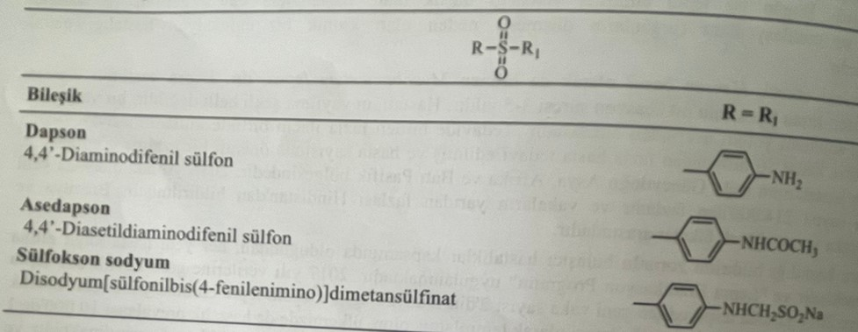
Dapsone: 4,4.-diaminodiphenyl sulfone (DDS)
Dapsone is obtained by hydrolysis of the acetyl groups of 4,4.-diaminodiphenyl sulfone formed by the reaction of two molecules of acetanilide with sulfuryl chloride.
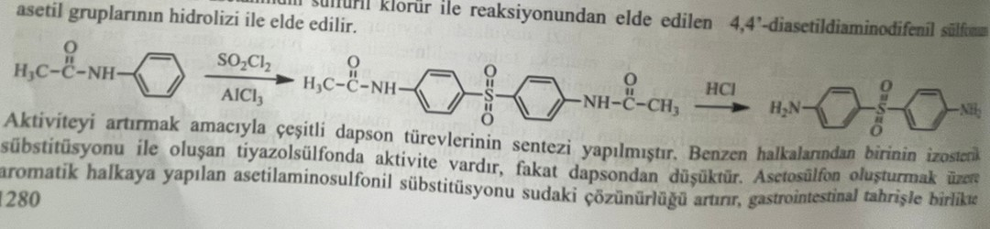
Various dapsone derivatives have been synthesized to increase activity. Activity is observed in thiazolesulfone formed by subunitation of one of the benzene rings. However, this activity is lower than that of dapsone. Addition of acetylaminosulfonyl to the aromatic ring to form acetosulfan increases water solubility. But activity is decreasing. Suloxane sodium is obtained as a result of combining methanesulfinate with dapsone.
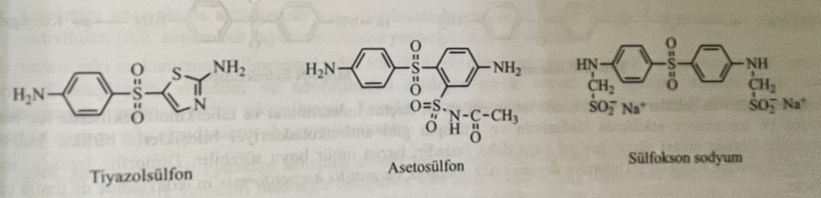
The structure-activity relationship for dapsone is as follows:
1) Addition of hydroxyl, amino, chloro, methoxy and methyl groups to the ring leads to the formation of inactive compounds.
2) As a result of replacing one of the amino groups with a hydroxyl, nitro- and hydroxylamino group, the activity decreases.
3) Substitution of both amino groups with hydroxyl leads to lower activity.
4) Restoration of the sulfonic group to the sulfoxide group leads to a decrease in activity. Its conversion to a thioether group leads to the disappearance of its activity.
5) Aldehyde-bisulfide complexes of amino groups, such as sulfoxone sodium, are also active compounds. Dapsone is formed during degradation in vivo.
The mechanism of action of sulfonoids is similar to sulfonamides. It acts as an inhibitor of folic acid. Therefore, the combination of dapsone with PASK is contraindicated. The drug is a weak base that does not dissolve in water. Although it does not dissolve, it is easily absorbed from the gastrointestinal tract. 70% binds to plasma proteins. After absorption, it spreads to all tissues. The main metabolite of dapsone is formed as a result of N-acetylation by the enzyme N-acetyltransferase in the liver. At the same time, as a result of the N-hydroxylation reaction, a metabolite derived from hydroxylamine is formed. None of these metabolites have a lepostatic action. Although acetylated metabolites of dapsone are inactive, hydroxylated derivatives also have serious hematological effects. Metabolite N-hydroxydiaminodiphenylsulfon causes methemoglobulinemia.
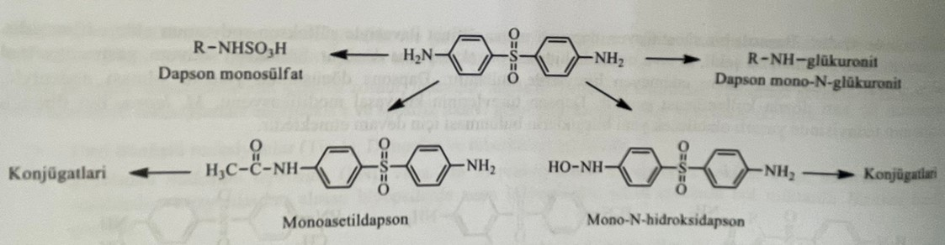
Dapsone is the drug of choice for all forms of leprosy. It is used separately for indeterminate and tuberculoid types and in combination with antimycobacterial drugs, such as clofazimin and rifampin, for dimorphic and lepromatous types. The treatment of lepromatous leprosy can last for 5 years or for life. Dapsone is also the drug of choice in the treatment of dermatitis herpetiformis.
The combined use of dapsone with p-aminobenzoic acid leads to a decrease in the anti-leprosy effect of the drug. If dapsone is used with the drugs probenecid and sulfinpyrazone, the concentration of dapsone in the plasma increases.
The most important known side effect of dapsone is hemolysis. The degree of hemolysis depends on the dose. At the same time, the drug causes abdominal pain, nausea, vomiting, anorexia. In patients with eating disorders, sulfone syndrome appears about a week after dapsone administration. This syndrome is characterized by fever, fatigue, exfoliative dermatitis, jaundice, lymphadenopathy, methemoglobulinemia and anemia.
Other connections
Clofazimine: N,5-bis(4-chlorophenyl)-3,5-dihydro-3-[(1-methylethyl)imino]-2-phenazinamine
Clofazim was first used in 1996 to treat progressive leprosy that did not respond to dapsone or streptomycin. This is a dark red, water-insoluble dye.
It is obtained as a result of the catalytic reduction of the glyoxal compound, formed by the reaction of chlorfazimine, N,5-bis(4-chlorophenyl)-3,5-dihydro-3-[(1-methylethyl)imino]-2-phenazinamine hydrochloride with isopropylamine in an ethanol medium.
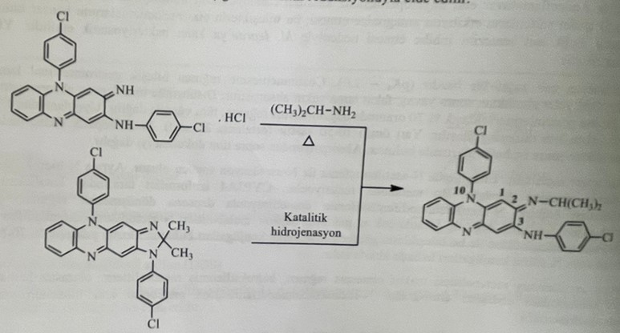
Several studies were conducted to study the relationship between the structure and activity of clofazimine. Thus, the functional groups attached to the imino group in the 2nd position, the p-chlororadical of the phenyl ring, attached to the C-3 and N-10 positions, and the compounds in the 7th position of the molecule were investigated. The structure-activity relationship is as follows:
1) The imino group in the C-2 position is important for activity. Replacing the imino group with alkyl and cycloalkyl groups leads to increased activity.
2) p-chloroaniline in positions C-3 and C-10 is important for activity. Halogen bonding of phenyl rings in C-3 and N-10 positions with p positions increases activity. The order of activity is as follows: Br > Cl > CH3 > EtO > H or F.
3) The increase in the activity of the studied analogues is directly proportional to the lipophilic properties.
Clofazim has a direct antimycobacterial and immunodepressant effect.
